THE OTER

V



This Newsletter published by and for the

League of Women Voters of Yakima County

PO Box 723, Yakima, WA 98907 509-452-3419

*We respectfully acknowledge that we are on the traditional land of the Yakama People.*

May, 2021

Vol.21, No 5

**CALENDAR**

Monday, May 24, 4:30 PM **LWVYC Annual Meeting.** Tentatively in-person at Windcrest Villa, 5910 W Lincoln Ave. **RSVP by Saturday, May 22**: [cbardill@gmail.com](mailto:cbardill@gmail.com) or [yakimacountylwvyc@gmail.com](mailto:yakimacountylwvyc@gmail.com) or 509-965-2351. *See article on pp 2-3.*

Tuesday, May 25, 5:30 PM **Community Conversation: Violence and Discrimination Against Asian Americans and Pacific Islanders** with Carrie Huie-Pascua and Dori Peralta Baker. Via Zoom or stream on LWVYC Facebook page. *See announcement below.*

Monday, June 7, 4:30 PM **Leadership Team Meeting.**

June 24 – June 28 **The Next 100 Years Defending Democracy: WA State League Convention.** Via Zoom.Event information and link to registration is at: <https://lwvwa.org/Convention-2021/> *See article on p 4.*

**MISSION STATEMENT**

Empowering Voters. Defending Democracy.

**VISION**

We envision a democracy

where every person has the desire,

the right, the knowledge, and the confidence

to participate.

**VALUE STATEMENT**

The League believes in the power of women to create a more perfect democracy.

March 26

+-

**Officers**

*President:*  Criss Bardill

*Secretary:* Karen Pilon

*Treasurer:* Janis Luvaas

**Leadership Team**

Quinn Dalan

Rhonda Hauff

(*also Membership*)

Kitty Jubran

Susan Kaphammer

Cheri Kilty

Kathy Lambert

Lee Murdock

*Voter Editor:* Susan Kaphammer

949-0127; susanlkap@gmail.com

The Board currently meets at 4:30 PM

the 1st Monday of each month via Zoom.

**All members are welcome.**

Contact Criss Bardill at 509-965-2351 or at [cbardill@gmail.com](mailto:cbardill@gmail.com) to “attend”

*Community Conversation…*

**Violence and Discrimination Against Asian Americans and Pacific Islanders**

Local and National Issues With

**Carrie Huie-Pascua** and **Dori Peralta Baker**

**Tuesday, May 25, 2021**

**5:30 PM**

Join at Zoom Link (information forthcoming)

Or Watch Live on the LWVYC Facebook Page

*League Conversations:*

*Informing the public on topics of interest.*

*Page 2*



**co**

***The Voter,*** April*, 2021 Page 2*

***The Voter,*** *May, 2021 Page 2*

***LWVYC President’s Column…***

**NOTES FROM CRISS**

I’m writing this the day after mailing your Annual Meeting packets, and am looking forward to an interesting and productive meeting, hopefully in person.  I encourage you to take time to read the excellent and comprehensive Homelessness Study, and to be prepared to discuss how we move forward in developing a Consensus Position on Homelessness in Yakima County.

In an update on our process of vacating our office at YUUC, I am very pleased to announce that the YWCA will be providing storage for our office supplies and recent records, as well as meeting space, and that Yakima Valley Museum has agreed to take our historical records and scrapbooks.  We have been culling our office, and we have another work party scheduled for May 13, which will hopefully get us ready for a move to the YWCA and delivery to the Museum.  We will be leaving most of the furnishings in the office, as the church that is buying the building welcomes any office furnishings current occupants want to leave in place.

The LWVWA Convention is scheduled for June 24-28 on Zoom.  Registration is $20.21, increasing to $50 on June 17.  I found the 2020 Council on Zoom to be very productive, and certainly a much less expensive alternative to attending a Convention in person.  The Convention is focused on the business of the State League, including election of new officers and board members, and based on our size, we are allocated 3 voting delegates. Cheri Kilty and I have volunteered, and I’m hoping someone not on the current Leadership Team would like to volunteer. It is an interesting way to learn about the structure and business of the League. Please let me know if you are interested or want more information.  Registration and information are now available at <https://lwvwa.org/Convention-2021/>.

And this is my last NOTES FROM CRISS as your President. We will be electing Cheri Kilty as our new President at our Annual Meeting. Cheri is the Executive Director of the YWCA, and I am very pleased to see her stepping into this role. Her political activism and her commitment to the work of the YWCA dovetails well with the values and goals of League.  Thank you for all the support and encouragement you have given me over the last 4 years, and I trust Cheri will experience the same.

– Criss Bardill

***LWVYC Annual Meeting…***

**AGENDA INCLUDES ELECTION OF LEADERS**

**AND CONSENSUS ON HOMELESS STUDY**

All members are invited and encouraged to attend our local League Annual Meeting on Monday, May 24, at 4:30 PM. Because a quorum of membership is required, please RSVP by Friday, May 22, at [yakimacountylwvyc@gmail.com](mailto:yakimacountylwvyc@gmail.com) or [cbardill@gmail.com](mailto:cbardill@gmail.com), or call Criss at 965-2351.

After a year of Zoom events only, this annual gathering is tentatively planned for in-person at the clubhouse at Windcrest Villa, 5910 West Lincoln Avenue, outside on the pool deck. Plan to wear your mask. While we will not be sharing a meal, you may bring beverage and/or snack for yourself. If necessary due to weather or Covid precautions, the meeting will be shifted to Zoom. This decision will be made by Saturday, May 22, and reported to members by email.

A major focus for this meeting is the completed *Study of Homelessness in Yakima County.* The study was initiated at our 2017 annual meeting. Since then, a committee including Betty Van Ryder,

*(continued on Page 3)*

***The Voter,*** *May, 2021 Page 3*

**AGENDA** (*continued from Page 2)*

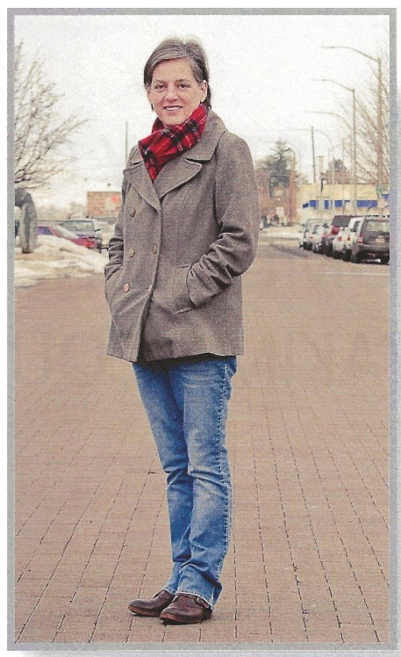

Carrie Hule-Pascua, Ellie Lambert, Jackie Call, Jackie Hertel, Marilyn Shearer and Mary Stephenson spent countless hours planning, working, thinking, researching and documenting the conditions and factors affecting homelessness in Yakima County. Lee Murdock provided valuable assistance in technical review and editing of the study report (included in your Annual Meeting packet).

This time-consuming, extensive study is meant to guide education and advocacy for a League position on homelessness. The next step is to ascertain a consensus position by consideration of several questions arising from the study. Review the study prior to our meeting to be prepared to offer input on questions about the balance between emergency services and permanent supportive housing, and about understanding homelessness as a social and health care issue rather than a crime or personal failing, as well as questions about other aspects of homelessness.

Additionally, members will elect a new president and Leader- ship Team members for our LWVYC. So plan to attend our Annual

*Ellie Lambert, to whom the Homelessness Study is dedicated in honor of her enthusiasm, insight, caring and courage.*

Meeting for this opportunity to hopefully see each other and

communicate in person.

The Mission of the League of Women Voters of Yakima County is Empowering Voters. Defending Democracy. Their vision is a democracy where every person has the desire, the right, the knowledge, and the confidence to participate. The League believes in the power of women to create a more perfect democracy. From the Introduction to *The Study of Homelessness in Yakima County*

***League Bylaw Changes…***

**LWVUS UPDATES STATEMENTS OF LEAGUE**

**PURPOSE AND MEMBERSHIP**

Our local League has updated our bylaws to align with specific language approved at the 2020 Annual National Convention of the LWVUS. The delegates mandated that Articles II and III of all local league bylaws include the following:

**ARTICLE II** **PURPOSE AND POLICIES:**

2. DIVERSITY, EQUITY AND INCLUSION. The League is fully committed to ensure compliance – in principle and in Practice – with LWVUS’ diversity, equity and inclusion policy.

**ARTICLE III**

(d) Those who are students are defined as individuals enrolled either as full or part time with an accredited institution.

These bylaw changes do not require ratification by membership, as they were mandated by National.  If you would like to receive a copy of our updated bylaws, let Criss know to email you the document. cbardill@gmail.com

***The Voter,*** *May, 2021 Page 4*

***State League Convention…***

**REGISTRATION NOW OPEN FOR UPCOMING**

**STATE LEAGUE CONVENTION**

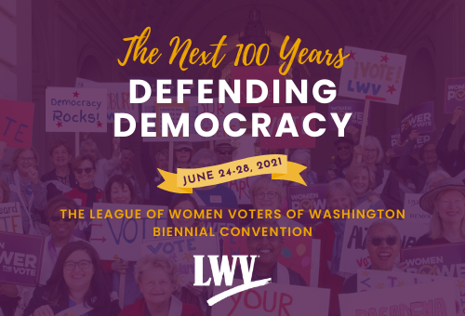

June 24 – 28 are the dates for the Biennial Convention of the League of Women Voters of Washington. To be held virtually via Zoom, registration is only $20.21 through June 17; registration raises to $50 after this date. Members may attend as delegates or non-voting attendees. Workshops and observing the business is also open to non-members.

“The Next 100 Years Defending Democracy” is the theme. Business will be conducted to frame the 2021-2023 biennium, including adoption of the Program of Work, election of officers and the board of directors, and approval of budget and bylaw amendments. In addition, various workshops will offer insights into key issues as well as sharing of ideas from League members across the state.

Criss, reports from her experience that the Convention offers a valuable and enjoyable chance to learn and be involved. The LWVWA website promises:

The convention is a great opportunity for new and long-term members to learn more about the League, meet members from across the state, and be inspired for our next 100 years. You do not need to be an official delegate of your local League to attend the convention! You may attend all of the programming and caucuses as an interested League member, and if you have a great League prospect who is not yet a member, you can encourage them to attend, too.

The Convention webpage at <https://lwvwa.org/Convention-2021/> provides a link to registration as well as links to documents for delegates to review prior to the event. As the Convention nears, more details will be provided at this site.

***LWVYC Annual Project…***

**YAKIMA COUNTY “TRY” UPDATED AND DISTRIBUTED**

The Yakima County ***T****hey* ***R****epresent* ***Y****ou* political directory, referred to as the “TRY,” has been updated for 2021 and is now in distribution. Kitty Jubran heads up the collecting of names and contact information for public servants from national offices to local school boards. Susan Kaphammer helps format the extensive listings into a handy brochure to be made available to the public at no charge.

Fewer copies were printed this year but the League added postcard-sized notices in Spanish and English that the directory is available on League of Women Voters of Yakima County facebook page at: [https://www.facebook.com/LWVYC](https://www.facebook.com/LWVYC ). Printed copies may be requested by contact the League at

yakimacountylwvyc@gmail.com or at: PO Box 723, Yakima WA 98907.

***The Voter,*** *May, 2021 Page 5*

***LWV Dues…***

**DUES POLICY AND SCHOLARSHIPS CLARIFIED**

You may have noticed in the April Voter some new language at the bottom of the Membership form, as follows:

*Please note: Our fiscal year is July 1 – June 30. Initial dues received before December 31 will be subject to renewal on June 30 of the following year. Initial dues received after January 1 will be subject to renewal on June 30 of the year following that year.*

*Examples: a) Initial dues paid October 10, 2020, renewal date June 30, 2021           b) Initial dues paid February 24, 2021, renewal date June 30, 2022*

This was done to coordinate our local dues with when the membership count is submitted to National League establishing our dues for the following year, as well as getting all members on the same renewal cycle of June 30.

In addition, please note this message on our Membership form:

*Scholarships are available for potential members who cannot afford dues. Please contact us at yakimacountylwvyc@gmail.com*

I (Criss) was reminded on a recent LWVWA President’s call that the state League has a scholarship fund for underwriting membership for individuals wanting to be active in League but unable to afford the dues.  The local League President completes a simple on-line application for the Membership Scholarship and forwards it to the State League. Please keep this in mind if you have an opportunity to encourage membership, especially with your DEI (Diversity, Equity, and Inclusion) lens.

STRONGER TOGETHER

**LEAGUE OF WOMEN VOTERS OF WASHINGTON**

**STATEMENT ON DIVERSITY**

The League of Women Voters is an organization fully committed to diversity, equity, and inclusion in principle and in practice. Diversity, equity, and inclusion are central to the organization’s current and future success in engaging all individuals, households, communities, and policy makers in creating a more perfect democracy.We will actively work to remove barriers to full participation in this organization on the basis of gender, gender identity, ethnicity, race, native or indigenous origin, age, generation, sexual orientation, culture, religion, belief system, marital status, parental status, socioeconomic status, language, accent, ability status, mental health, educational level or background, geography, nationality, work style, work experience, job role function, thinking style, personality type, physical appearance, political perspective or affiliation and/or any other characteristic that can be identified as recognizing or illustrating diversity.



[This Photo](http://whitelocust.wordpress.com/wake-up-world/the-dangers-of-diversity) by Unknown Author is licensed under [CC BY](https://creativecommons.org/licenses/by/3.0/) for adapting and sharing



**LEAGUE OF WOMEN VOTERS**

**OF YAKIMA COUNTY**

**Empowering Voters. Defending Democracy.**

**Cordially invites you to:  JOIN US!**

Name:____________________________________________     M**embership Categories:**

Address:__________________________________________     _______$10 Student

______________________________________________________     ________$60 Basic

Phone:____________________________________________     _______$40 Each

                                                                          Additional Family

Member at the Same

E-Mail: ___________________________________________      Residence

Scholarships are available for potential members who cannot afford dues. Please contact us at [yakimacountylwvyc@gmail.com](mailto:yakimacountylwvyc@gmail.com)

Additional Sustaining Gift:  $60_______ $40 _____ $25 _____ Other:_______

Your Sustaining Gift will help support our local activities.

**Make checks payable to:** LWVYC

**And mail to:** LWVYC, PO Box 723, YAKIMA WA 98907

Please note: Our fiscal year is July 1 – June 30. Initial dues received before December 31 will be subject to renewal on June 30 of the following year. Initial dues received after January 1 will be subject to renewal on June 30 of the year following that year.

Examples: a) Initial dues paid October 10, 2020; renewal date June 30, 2021

               b) Initial dues paid February 24, 2021; renewal date June 30, 2022