THE OTER

V

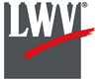

This Newsletter published by and for the

League of Women Voters of Yakima County

PO Box 723, Yakima, WA 98907 509-452-3419

*We respectfully acknowledge that we are on the traditional land of the Yakama People.*

August, 2021

Vol.21, No 8

**MISSION STATEMENT:**

Empowering Voters. Defending Democracy.

**VISION:**

We envision a democracy

where every person has the desire,

the right, the knowledge, and the confidence

to participate.

**VALUE STATEMENT:**

The League believes in the power of women to create a more perfect democracy.

**CALENDAR**

Tuesday, August 24, 5:30 PM **Community Conversation: Opioid Epidemic in Yakima County.** Panel Discussion including Theresa Adkinson, Triumph Treatment; Sheriff Robert Udell, Yakima County; Erika Ochoa, Yakima Health District. *See announcement below.*

Monday, September 7, 4:30 PM **Leadership Team Meeting** via Zoom.

March 26

+-

**DUES REMINDER**

Annual dues for the LWVYC come due on July 1 for the following year. If you have already renewed, THANK YOU! If you newly joined after the first of this year, you are covered until July, 2022. If you need to renew, see the form attached to this newsletter.

**Officers**

*President:*  Cheri Kilty

*Secretary:* Karen Pilon

*Treasurer:* Janis Luvaas

*Membership:* Rhonda Hauff

**Leadership Team**

Criss Bardill

Quinn Dalan

Kitty Jubran

Susan Kaphammer

Lee Murdock

*Voter Editor:* Susan Kaphammer

949-0127; susanlkap@gmail.com

The Board currently meets at 4:30 PM

likely on Zoom. Watch email for link.

**All members are welcome.**

*August Community Conversation…*

**Opioid Epidemic in**

**Yakima County**

**Tuesday, August 24, 2021, 5:30 PM**

**Online Event**

Join the conversation with a panel of

community leaders including:

**Theresa Adkison**, Triumph Treatment

Yakima County **Sheriff Robert Udell**

**Erika Ochoa**, Yakima Health District

Watch live or stream later on the

LWVYC Facebook Page

*League Conversations:*

*Informing the public on topics of interest.*

*Page 2*



**co**

***The Voter,*** August 2021Page 2

***LWVYC President’s Column…***

**NOTES FROM CHERI**

I hope everyone has had a good summer and is staying healthy.

Locally we are working on a candidate forum for the fall. It is important to learn about the candidates and use our vote to shape what happens at all levels of government. *See article below.*

One of the State League projects we are participating in is on election credibility. The theme of the project is to orient each county auditor/elections official with our overall project to combat election misinformation which is causing voter confusion and distrust.  As a non-partisan good government organization, we may be in a good position as a well-regarded third party to persuade voters that elections are secure, accurate, and fair, and are conducted by professionals with high standards. Each league is meeting with our local county auditor to interview them on what they are hearing from voters and voter concerns along with how we can partner with election people throughout the state to ensure we are sharing accurate content. *See article on page 3 of July issue of* The Voter*.*

One of our goals is to increase membership. I invite you to ask one person you know to join our Yakima League.

– Cheri Kilty

***Candidate forums…***

**GET TO KNOW LOCAL CANDIDATES**

Voter Education is a major focus for the League of Women Voters. Candidate forums provide voters important information and insights. Every race at each level of government – national, state, county, city and school district – has consequences for our personal lives and for our democracy. Some local forums are already being planned.

Our LWVYC is making plans for a candidates’ forum to be held around the middle of October to coincide with the October 15 release of ballots for the November 2 General Election. This forum will likely be online. Watch for details in future issues of *The Voter,* as well as on news and social media.

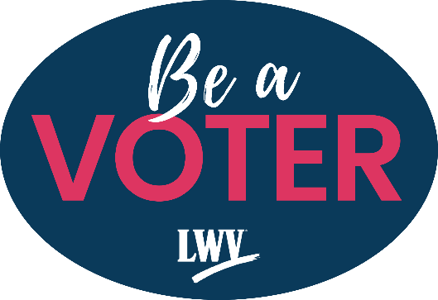 On Tuesday, September 21, 6:00 to 7:00 PM, candidates for Yakima County Commission will be hosted at the Yakima Convention Center by the Central Washington Home Builders Association, Yakima Association of Realtors®, and the Greater Yakima Chamber of Commerce. According to the announcement, “Candidates will be asked about their vision for the future of Yakima County and how they would use their time on the commission to help area housing providers and employers face the challenges ahead.” Organizers also noted, “Attendees will have a chance to submit their own questions to be answered live at the event.”

Additional opportunities to learn about candidates include news reports, campaign literature, voters guides, and the League’s [VOTE411](https://www.vote411.org/) website (<https://www.vote411.org/>). These support the LWV vision of, “a democracy where every person has the desire, the right, the knowledge, and the confidence

to participate.”

***The Voter,*** August 2021Page 3

***September Community Conversation…***

**SEX TRAFFICKING HAPPENING IN YAKIMA COUNTY**

Debbie Brockman shared her knowledge and concerns about local sex trafficking at our League-sponsored Community Conversation on July 7. With 25 years working in the field, Ms. Brockman has been Program Manager of Aspen Victim Services for the past three years. The Community Sexual Assault Program provides a 24 hour crisis line; information, referral and community awareness; and personal support for victims including legal advocacy and medical support.

Human trafficking involves the use of force, fraud or coercion to obtain labor or services. Money is the driver for this fastest growing world-wide criminal activity. Around the world, human trafficking for labor is more common while in the U.S. the trafficking is more likely to be for sex. Commercial Sexual Exploitation of Children (CSEC) is a particular category defined as sexual activity for financial benefit or traded for anything of value given or received. The full extent of trafficking crimes is uncertain, given gaps in identifying and recording incidents of human and sex trafficking.

Victims can be anyone irrespective of age, gender, or citizenship. But risk factors include recent migration or relocation, substance use, mental health concerns, LGBTQ+ identities, involvement in child welfare, homelessness, and lacking resources and support. Similar to perpetrators of domestic violence, traffickers exploit an individual’s vulnerability. “Grooming” may begin with what appears to be kindness and help. Then power and control are exerted by physical abuse, emotional abuse, isolation, threats and/or economic coercion. Victims may deny the situation, seeing the trafficker as a romantic partner. Additional aspects that make it difficult for victims to seek and accept help include feeling trapped, experiencing shame, and receiving threats to violence. Countering some myths about trafficking, Ms. Brockman explained:

* It does happen in Yakima County.
* By legal definition, trafficking does not always involve being moved from place to place.
* Trafficking occurs in legitimate business settings as well as underground, “shady” enterprises.
* Initial consent is irrelevant to the crime; if the victim believes serous harm can occur, it is trafficking.
* Payment is not required for the crime; anything of value given or received qualifies.
* Physical restraint, abuse or threat is not required for the crime; non-physical means of control include debt bondage.

Common in our community is “survival sex.” Vulnerable individuals include those who lack safe living spaces and who are experiencing food and/or financial insecurity. Survival sex involves trading sex for money, food, water, a place stay, alcohol or drugs. This becomes commercial sexual exploitation if the person offering “help” is demanding sex in exchange. Victims may not recognize the reality of the situation because of trauma bonds to the traffickers.

Warning signs of being groomed or trafficked could include: chronic running away or truancy, excess cash or unexplained expensive items, hotel room keys, multiple cell phones, body branding, false IDs, erratic behavior or dramatic personality change, disengaging from usual activities such as school and sports, wearing provocative clothing, fixation on a new “boyfriend,” hanging out with an older adult.

Working with young people who may be exploited requires a delicate approach, including:

* Compassionate, non-judgmental attitude at all times – don’t show shock, dismay or disgust,
* Consistency and follow through – never promise what you can’t deliver,
* Trust and relationship-building – this slow process will likely include some acting out and testing,
* Cultural competence and check your own beliefs and biases,
* Focus on safety – housing, harm reduction, safety strategies,
* Self-determination and empowerment – provide information for informed decisions.

*(Continued on Page 4)*

***The Voter,*** August 2021Page 4

**SEX TRAFFICKING HAPPENING IN YAKIMA COUNTY** *(Continued from Page 3)*

Debbie Brockman sees some progress in Yakima in recognition of and intervention for victims of trafficking. Support includes housing and employment options, trauma-informed social, medical and legal services, and acceptance of a harm-reduction model, realizing that immediate rescue is not reasonable. Yakima has a CSEC Task Force at work among programs and agencies. The goal is that our community provide a continuum of competent services.

In a caring community, words matter. Ms. Brockman urged us to pay attention to and challenge harmful terms tending to minimize crimes and shame victims. She has actually encountered such terms in court cases and we may encounter similar comments in the community. These include:

* Underage woman; no such thing, if underage the “woman” is a child
* Child prostitute; again, no such thing
* Sex with a minor; which is rape
* Non-consensual sex; also rape

Ms. Brockman concluded, “There remains lots of community education to do.” This Community Conversation can help toward that end, particularly with the awareness, attention and work of our League and individual members.

***Yakima County League History…***

**YAKIMA COUNTY LEAGUE ADVANCES**

**FROM PROVISIONAL STATUS**

This is the second installment of a series adapted from a typed ten-page document titled, “A History of the League of Women Voters of Yakima County,” by co-authors Kara Kondo, Geneve Bowden, Marge Van Scoy, Laura Hopp, Pat Ball, Charlotte Kendrick, and Marilyn Lane. The first article in last month’s *The Voter* covered the very beginnings of our chapter from March 1950 through the middle of 1951, where this article picks up the history.

*Editor’s Note: Direct quotes from “A History of the League…” will be indicated by quotation marks. Some details and names will be omitted. At the conclusion of the newsletter series, the entire document will be made available to interested members*.

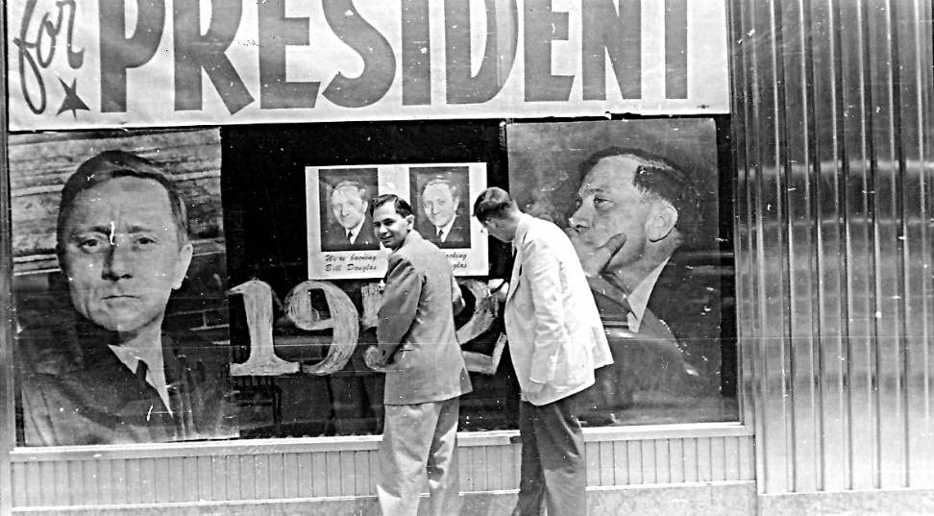**Developing as a Local League**

Barely a year after the first organizational meeting to form a Provisional League, the Yakima President, Laura Hopp, was delegate to the 1951 State Convention in Spokane. Around this time “was our first finance drive…resulting in $230 collected in the community.”

The “Know Your Town” survey was typed “and 200 copies were mimeographed [and] distributed to schools, libraries, public officials, and

State and U. S. Leagues of Women Voters

Window display promoting William O. Douglas for President, 1952.

*Photo from Yakima Memory,* *an online collaboration between Yakima Valley Libraries and*[*Yakima Valley Museum*](https://www.yvmuseum.org/)*.* [*https://archives.yvl.org/*](https://archives.yvl.org/)

as requested.”

*(Continued on Page 5)*

***The Voter,*** August 2021Page 5

**YAKIMA COUNTY LEAGUE ADVANCES. . .**  *(Continued from Page 4)*

Two study units met twice monthly in members’ homes, one on Monday evenings and the other Thursday mornings. “A better understanding of political issues developed through lively discussions.” The League also held “open meetings, with knowledgeable outside speakers,” on topics including juvenile protection and international trade. “Perhaps our greatest satisfaction in this busy period came in meeting goals required for official League status,” confirmed in May, 1952, by a letter from the National President of LWV. This was followed by hosting the State Convention in June, 1953, “assisted by all members of the League.”

“We learned a lot in two years. We learned that the LWV existed on three levels: national, state and local, and that we were members of all three. Our purpose in the beginning was to learn about government through a non-partisan approach. It is still our purpose but we discovered that, in addition to studying, we were to become an action group. We actively supported issues on which we had studied and reached consensus, and this we call Program Action. We also provided information to the community on elections, and we call this part of our endeavor Voters Service.”

*(Learn more about the Programs and Services our history story continues in the September issue*.)

***Message from LWVUS. . .***

**REMAINING NONPARTISAN IN HYPER-PARTISAN TIMES**

So many issues today are framed in partisan terms that it can feel impossible to communicate at all without being accused of taking a side. “If you believe this, then you must be a progressive.” “If you oppose that, then you align with conservatives.” Being painted into ideological corners because of a stance the League takes is not a new phenomenon, but it continues to be one that undermines a vibrant democracy: discussion, discourse, and listening to other points of view are what makes democracy work.

More than 100 years ago, the League of Women Voters of the U.S. was founded to be a nonpartisan voice for American women who wanted free, fair, and open elections, above all else. Our founders believed that voters must always have the facts, no matter how difficult those facts could be to accept, especially when it challenges one’s deeply held beliefs about a candidate or political party. Our founders were attacked for taking positions rooted in fact back then, and not much has changed today. League leaders continue to face this challenge and often stand accused of being partisan for our efforts to advance democracy.

A few reminders from the national League:

**Issues are not partisan:** The League’s advocacy work is issued based, and we arrive at our positions after careful study and input from our members in communities across the country. We never derive our positions from politicians, and even when candidates or parties support the same issue, we never endorse them.

**Nonpartisan does not mean apolitical:**League members represent opinions and positions from across the American political spectrum. What brings us together is our commitment to voter empowerment—especially empowering women voters—and defending democracy. Standing up for these values is not a partisan narrative but a way to advance inclusion.

**Democracy is a civil rights issue:**Our mission to “empower voters and defend democracy” has not changed in our more than 100 years. What has changed is the need to defend democracy in the face of voter suppression and the wealth of misinformation that threatens to divide us as a nation and undermine our democracy.

Even though it may be a challenge, especially at the state and local level, we must avoid the appearance of partisanship when publicly addressing racial injustice in this heightened climate. We must stand on the side of justice, even at the risk of being accused of partisanship. It is our moral obligation to demand a more just and equitable world for everyone in our communities.

***The Voter*,** August, 2021 Page 6

**LEAGUE OF WOMEN VOTERS OF WASHINGTON**

**STATEMENT ON DIVERSITY**

The League of Women Voters is an organization fully committed to diversity, equity, and inclusion in principle and in practice. Diversity, equity, and inclusion are central to the organization’s current and future success in engaging all individuals, households, communities, and policy makers in creating a more perfect democracy.We will actively work to remove barriers to full participation in this organization on the basis of gender, gender identity, ethnicity, race, native or indigenous origin, age, generation, sexual orientation, culture, religion, belief system, marital status, parental status, socioeconomic status, language, accent, ability status, mental health, educational level or background, geography, nationality, work style, work experience, job role function, thinking style, personality type, physical appearance, political perspective or affiliation and/or any other characteristic that can be identified as recognizing or illustrating diversity

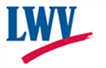

**LEAGUE OF WOMEN VOTERS**

**OF YAKIMA COUNTY**

**Empowering Voters. Defending Democracy.**

**Cordially invites you to:  JOIN US!**  **New Member Renewing Member**

Name:____________________________________________     M**embership Categories:**

Address:__________________________________________     _______$10 Student

______________________________________________________     ________$60 Basic

Phone:____________________________________________     _______$40 Each added

                                            family member at the same

residence

E-Mail: ___________________________________________

Scholarships are available for potential members who cannot afford dues. Please contact us at [yakimacountylwvyc@gmail.com](mailto:yakimacountylwvyc@gmail.com)

Additional Sustaining Gift:  $60_______ $40 _____ $25 _____ Other:_______

Your Sustaining Gift will help support our local activities.

**Make checks payable to:** LWVYC **And mail to:** LWVYC, PO Box 723, YAKIMA WA 98907

Please note: Our fiscal year is July 1 through June 30. Initial dues received before December 31 will be subject to renewal on June 30 of the following year. Initial dues received after January 1 will be subject to renewal on June 30 of the year following that year.

Examples: a) Initial dues paid October 10, 2020; renewal date June 30, 2021

               b) Initial dues paid February 24, 2021; renewal date June 30, 2022