THE OTER

V

We respectfully acknowledge that we are on the traditional land of the Yakama People.
This Newsletter published by and for the
League of Women Voters of Yakima County
PO Box 723 Yakima WA 98907 509-452-3419
December, 2019
Vol.19, No 12

CALENDAR

Tuesday, December 19, 11:30 AM No-Host Lunch and Tour of Holiday Lights Extravaganza! Meet at Zesta Cucina, 5110 Tieton Drive, Yakima. See article below and attached flyer.

Monday, January 6, 4:00 PM Leadership Team Meeting. LWVYC office at Unitarian Universalist Church, 225 N 2nd Street, Yakima.

Tuesday, January 21, 5:30 PM Forum on Strong Mayor vs City Council/City Manager Proposal. ESD 105 Conference Room, 33 S 2nd Avenue, Yakima.
See Notes from Criss below.

Note: No League Conversation scheduled for December.

MISSION STATEMENT
Empowering Voters. Defending Democracy.

VISION
We envision a democracy
where every person has the desire,
the right, the knowledge, and the confidence
to participate.

VALUE STATEMENT
The League believes in the power of women to create a more perfect democracy.

March 26

April1, 4 PM

Officers
President: Criss Bardill
Secretary: Karen Pilon
Treasurer: Janis Luvaas

Board of Directors
Quinn Dalan
Cynthia Garrick
Rhonda Hauff
Kitty Jubran
Susan Kaphammer
Cheri Kilty
Kathy Lambert
Marilyn Shearer
Elaine Smith

Voter Editor: Susan Kaphammer
949-0127; susanlkap@gmail.com

The Board meets at 4:00 PM the 1st Monday of each month at the League office at the UUCY Church, 225 N 2nd Street, Yakima
All members are welcome to attend.

NOTES FROM CRISS

At our December Leadership Team meeting, The Yakima League agreed to conduct a community forum on the Strong Mayor vs City Council/City Manager proposal that will be on the February 11 Special Election ballot.
The forum will be on Tuesday, January 21, at 5:30 – 7 PM, in lieu of our monthly League Conversations, and will be at the ESD 105 Conference Room. We will have 2 participants from each side who will be seated together at the front of the room. Each side will give an opening statement and then take written questions from the audience. Sarah Augustine, who has so ably moderated our recent candidate forums, will serve as moderator for this forum.
I hope you will help spread the word for this event. Flyers and PSA’s will be forthcoming as details are nailed down.
(Continued on Page 2)

(Continued on Page 2)

The Voter, December, 2019 Page 2

NOTES FROM CRISS (Continued from Page 1)

Five League members and two League friends met at the Yakima Valley Museum on Sunday, Dec 1st, to decorate our holiday tree celebrating the 100 Anniversary of the League and the 17th Amendment for the Museum’s Holiday Lights Extravaganza. The event runs through Saturday, December 14. I hope you will support this non-profit fundraiser and enjoy the 30+ trees on display (see attached flyer).

November Conversation…

DR. CATE DETAILS IMPACTS OF CLIMATE CHANGE

At our November Conversation, Dr. Sara Cate reviewed a broad range of information about the impact of climate change on human health. Dr. Cate’s experiences as a family physician have confirmed for her what she has learned through a long-time interest in and study of climate change.
The report, “Health at Risk,” represents the increasing awareness of Washington physicians that our health is harmed by climate change. Impacts to our earth -- rising temperatures, more extreme weather, rising sea levels and increasing carbon dioxide levels – each threaten the health of individuals and entire populations. Dangers include heat-related illness and death, respiratory allergies and asthma, spreading diseases including malaria and Lyme disease, and diminished water and food supplies leading to malnutrition and diarrheal disease. Of no less concern are mental health impacts and social instability including forced migrations and civil conflicts.
While surveys reveal Americans are concerned about pollution. 83% agree that clean air is a personal right that should be available to all people. But the public has not been making the connection between climate and health. Only 14% identified respiratory problems and only 6% identified extreme weather illness, injury and death as related to climate change. Dr. Cate works to increase the understanding by spreading the message at venues such as this conversation and through her work with the Citizens Climate Lobby.
The Impacts of Climate Change on Human Health in the United States: A Scientific Assessment (available online at https://health2016.globalchange.gov/) was developed over three years by a broad range of experts in climate-change science and public health. Released in April, 2016, the report reinforces that climate change is a significant threat not just in the future but right now.
Our area of the country is certainly not immune to the health dangers. The Medical Society Consortium on Climate and Health identifies extreme temperatures, wildfires, and mental health and well-being as specific climate harms experienced in our Pacific Northwest region. The Union of Concerned Scientists provide a “Killer Heat Interactive Tool” (available at https://www.ucsusa.org/ resources/killer-heat-interactive-tool). This shows that the last three decades of the 20th century Yakima County experienced an average of 6 days per year of over 90 degree heat. With current practices, we will more than triple that to 20 days per year by midcentury and up to 38 days per year by the end of the 21st Century. Taking immediate and aggressive action as outlined in the Paris accord is estimated to hold the occurrences of over 90 degree heat to 17 days per year. Dr. Cate has seen in her practice increased illnesses due to wildfires. Yakima’s 2019 air quality is worse than ever before recorded and ranks 6th in the nation for highest level of short term air pollution. She has also noted her patients exhibit the stresses to mental health that heat and illnesses cause.

(Continued on Page 3)

The Voter, December, 2019 Page 3

(November Conversation – Continued from Page 2)
Dr. Cate sums up the situation, “Climate change hurts real people, right now.” The public, particularly policy makers, need to realize what is at stake. Despite the challenges, she sees reason to hope. A bi-partisan climate caucus now exists in the senate and house. House Resolution 763, The Energy Innovation and Carbon Dividend Act of 2019, has been introduced with bi-partisan support “to encourage market-driven innovation of clean energy technologies…and leave a healthier, more stable, and more prosperous nation for future generations.”
Dr. Cates closed with a call for us to act however we can. Share what you learn and experience related to climate change. Contact legislators, particularly Congressional Representatives, to support HR 763, Energy Innovation and Carbon Dividend Act. Ask for and support emerging efforts to draft local and regional climate adaptation plans. Resist the inclinations to set aside climate concerns or to be overwhelmed by the enormity of the issue. Believe that we can do something together, but we must act.

LWVYC Project…
CHRISTMAS TREE CELEBRATES 100 YEARS OF LEAGUE
AND WOMEN’S RIGHT TO VOTE

A group of LWVYC members, thankfully assisted by League friends Kim Brewer and Rick Mains, enjoyed a few hours decorating our 100 Year LWV Anniversary tree for the Yakima Valley Museum Holiday Lights Extravaganza. As the pictures attest, all had a great time and are pleased with the results.
To celebrate and share this project, we have booked space upstairs at Zesta Cucina at 11:30 on Tuesday, December 10, to gather for a no-host lunch and then tour the Museum as a group. We hope you can join us, and please RSVP by the Dec 9 to Criss, phone 965-2351, if yes so we can give the restaurant a head count. Please also let her know if you would like to have someone pick you up. Several of us would be more than happy to give rides. And League friends and/or potential members are very welcome.
If you are unable to join us on December 10, we hope you will take the opportunity to visit the Museum during the Extravaganza, lasting through December 14. Your admission will grant you the opportunity to vote for a favorite tree (OURS!) which will generate some funds for our organization.
Photos by Criss Bardill and Kim Brewer

Ready with the ornaments? Decorate!

(Continued on Page 4)

The Voter, December, 2019 Page 4
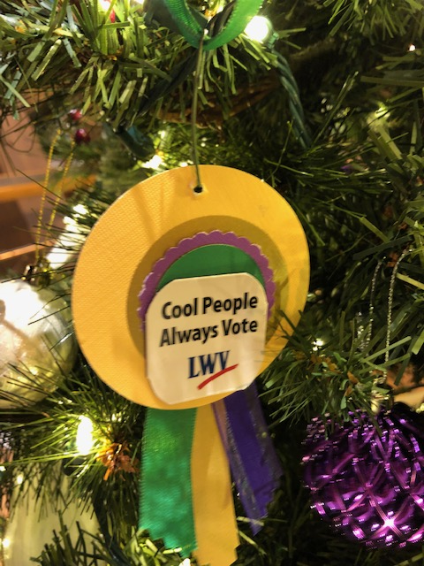
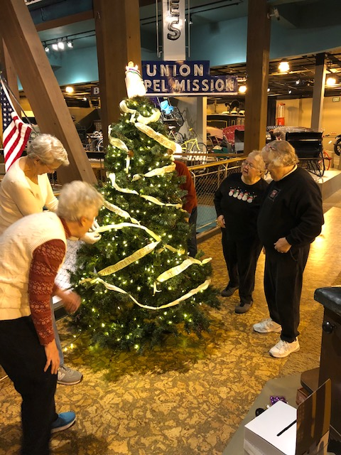
(Christmas Tree – Continued from Page 3)
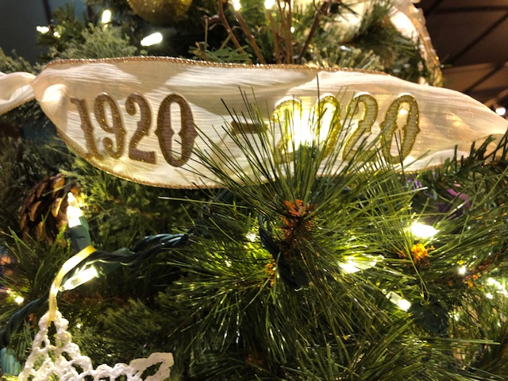
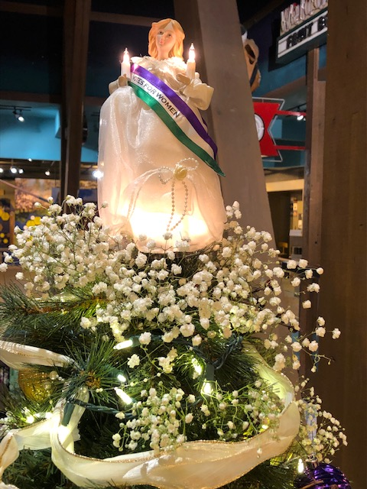
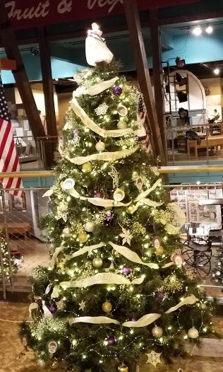
Above: One worker; three supervisors!

The Voter, December, 2019 Page 5

National League Position …
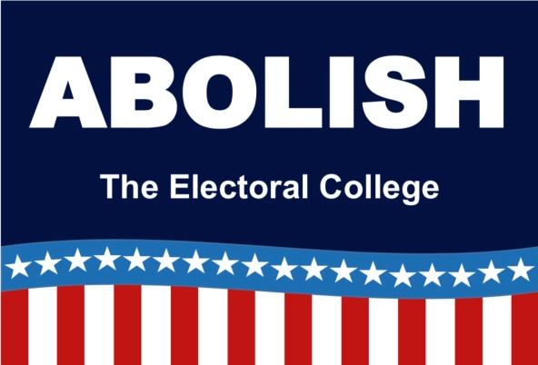
The League of Women Voters has taken the position that the Electoral College should be abolished in favor of a direct popular vote. Adopted in 1970 and updated in 2010, the significance of this effort has been highlighted by election controversies through the past few election cycles.
Why does the League of Women Voters take the position to abolish the Electoral College? It’s really very simple. It comes down to the concept of one-person, one-vote. The unintended result of the Electoral College is to put the choice of President and Vice-President in the hands of voters in only a few so-called “battleground states,” or “swing states.” This creates a documented dis-incentive for voters in other states to cast their ballots.
The Electoral College system polarizes our electorate and exaggerates our sense of being a divided nation, a nation of “red” versus “blue.” This damages our sense of national unity and our ability to see the great variety of public opinions that exist everywhere and that deserve to be heard. Indeed, they need to be heard, as diverse opinions are as critical to democracy as the vote itself.
The results in two recent elections point us, of course, to another serious problem with the Electoral College, which is that it can lead to a presidential winner who did not receive a majority of the votes. This has happened five times in our history, including Bush v Gore in 2000 and Trump v Clinton in 2016. This is the main reason most people find the Electoral College troubling.
Direct election by popular vote would ensure that every person is equally represented, regardless of where they live. Voters from swing states would count just the same as voters from non-swing states. Voters from the city would count just the same as voters from the country. A California Republican’s vote would count just the same as a California Democrat’s. We no longer would be voting by state, but by person. THIS is what the framers intended when they unanimously agreed with James Madison’s statement that the “President is to act for the people not for [the] States.”
Extensive information and materials are available through the website: Electoral College Reform: Why We Should Abolish the Electoral College and How to Do It. (URL: https://www.lwvwilmette.org/electoral-college-reform.html)

League of Women Voters of Yakima County
Cordially invites you to: JOIN US!

Name:________________________________________________ Date:_______________

Address:__________________________________________________________________

Phone:____________________________ E-Mail: ________________________________

Membership: ______$60 Basic______$40 Each additional family member at same residence
Sustaining Gift: $60 _____ $40 _____ $25____ Other_______
Make checks payable to:
LWVYC
PO Box 723
YAKIMA WA 98907
Your Sustaining gift will help support our local activities.

*Please Note Annual Dues Distribution:
National: $32 State: $19 LWVYC retains: $9

