THE OTER

V

We respectfully acknowledge that we are on the traditional land of the Yakama People.
This Newsletter published by and for the
League of Women Voters of Yakima County
PO Box 723 Yakima WA 98907 509-452-3419
July, 2020
Vol.20, No 7

CALENDAR

Online: Monday, August 3, 4:30 PM. Leadership Team Meeting. Via Zoom.

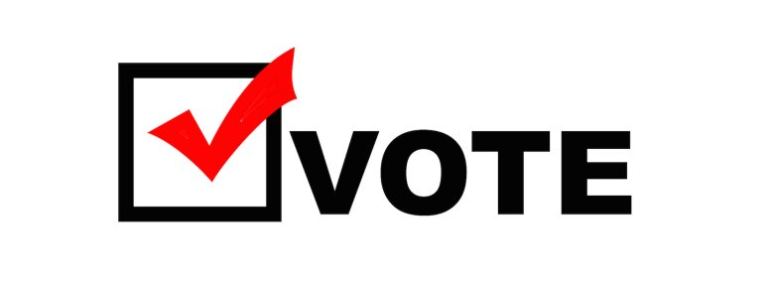
Tuesday, August 4, 2020. Primary ballots due!
Go to https://www.vote411.org/ for ballot and candidate information. See additional information in this issue.

MISSION STATEMENT
Empowering Voters. Defending Democracy.

VISION
We envision a democracy
where every person has the desire,
the right, the knowledge, and the confidence
to participate.

VALUE STATEMENT
The League believes in the power of women to create a more perfect democracy.

March 26

April1, 4 PM

LWVYC President’s Column…

NOTES FROM CRISS

The Yakima County LWV is moving ahead with plans for a virtual Gubernatorial Forum in late September or early October. The NAACP and the Yakima Herald Republic have been invited to co-sponsor. This will be a post-primary debate so only the final two candidates will be invited. More information will be forthcoming on our Governor forum as details are nailed down.
The State League is working with the candidates and is helping local Leagues to organize other virtual Forums for both the primary and the general elections. The LWV of Tacoma-Pierce County sponsored the Lieutenant Governor Primary Forum on July 9th. The Spokane Area LWV is sponsoring a July 16 Secretary of State Primary Forum.
If you have not viewed these previously, the recordings can be watched online from the LWV of Washington forums webpage: https://lwvwa.org/Forums
This page also keeps an updated list of forums around the state. Continued on Page 2

Continued on Page 2

Officers
President: Criss Bardill
Secretary: Karen Pilon
Treasurer: Janis Luvaas

Leadership Team
Quinn Dalan
Rhona Hauff
(also Membership)
Kitty Jubran
Susan Kaphammer
Cheri Kilty
Kathy Lambert
Anita Monoian
Lee Murdock

Voter Editor: Susan Kaphammer
949-0127; susanlkap@gmail.com

The Board currently meets at 4:30 PM
the 1st Monday of each month via Zoom.
All members are welcome.
Contact Criss Bardill at 509-965-2351 or at cbardill@gmail.com to “attend”

Page 2

co

The Voter, April, 2020 Page 2

The Voter, July, 2020 Page 2

NOTES FROM CRISS Continued from Page 1

Thank you to Leadership Team member Quinn Dalan for volunteering to manage our Facebook account and establish an Instagram account. It is so important for us to have an active presence in social media in order to attract the attention of younger generations. Please check out and “like” our facebook page at https://www.facebook.com/LWVYC/ and send us an Instagram message at https://www.instagram.com/lwv_yc/
At our annual meeting, we had two volunteers for our 2021 Nominating Committee: Dori Baker and Lee Murdock. Lee was also elected as a new member of our Leadership Team. Our by-laws call for the Nominating Committee to consist of two members from the general membership and one member of the Leadership Team. Since Lee will serve in the Leadership slot, we will need one more member from our general membership. Please let me know if you are interested in serving on the Nominating Committee, and if no one steps forward, I will be making calls later in the fall to do some “arm twisting”.
I was disappointed to learn the Sunfair Parade has been canceled, although I certainly support the reasoning. We had reserved an old fashion wagon at the Central WA Agricultural Museum and hoped to fill it with members and friends, some dressed in suffrage apparel, in celebration of our 100th Anniversary and the 100th Anniversary of the 19th Amendment giving women the right to vote. I long for the time, as I know you do, when we can safely gather in person for our League work and pleasure.
And, finally, if you haven’t already, please remember to renew your membership, which was due July 1. A renewal form is attached to this Voter, but you can simply mail your check to our PO Box with a notation that it is for dues. Please enclose a note explaining any amount in excess of the $60 basic dues. – Criss Bardill

LWV Election Information…

VOTE411 INFORMS VOTING DECISIONS

The LWV Vote411 online primary guide for Washington State has been published. You may now submit your address and see all of the candidates who will appear on your ballot. Note which ones have responded and which have not, and compare their answers. If there are candidates of interest to you who have not yet responded, this is a good time to give them a nudge. Ballots will not be due for a couple of weeks, so voters will still have a chance to see their answers before voting.
You may also get a list of all the races in the state, by going to Change Address and selecting All Races.
See the VOTE411 statement of purpose below. Check it out for yourself and refer other voters to google Vote411 at: https://www.vote411.org/ballot

The Voter, July, 2020 Page 3

LWV YC Leaders…

OFFICERS AND LEADERSHIP TEAM ELECTED

At our local League 2020 Annual Meeting on June 15, officers and Leadership Team members were elected. Officers will continue with Criss Bardill finishing one more year in her term as President, Karen Pilon re-elected as Secretary, and Janis Luvaas re-elected as Treasurer. Rhonda Hauff was re-elected to manage Membership and to continue on the Leadership Team. Also re-elected to the Leadership Team was Kathy Lambert and Kitty Jubran. Continuing their terms on Leadership Team are Cheri Kilty, Susan Kaphammer, and Quinn Dalan.
Newly elected to the Leadership Team are Lee Murdock and Anita Monoian. A hearty welcome and sincere thank you to these members for their acceptance of responsibility. We look forward to their sharing of experience, knowledge, and energy!

A huge note of appreciation and virtual applause to Cynthia Garrick and Marilyn Shearer who are leaving the Leadership Team, but not our organization. Their efforts have helped sustain and improve our League of Women Voters to be a force in Yakima County. Thank you!

StrongerTogetherStrongerTogetherStrongerTogetherStrongerTogether

LWV Promotion…

WANT SOME LWV SWAG?

Our Administrative Director in the State League office, Amy Peloff, created a great design that was used for the complementary masks the registrants for the 2020 virtual Council received. The design has been established at Redbubble for a big variety of products available for viewing and purchase at https://www.redbubble.com/shop/ap/51434862
Items offered include the still-essential masks, phone cases, pillows, totes, socks – yes, socks! – and more. You can deck yourself out with our important civic message encouraging voting.
The State League gets a 20% cut on all orders, so have fun ordering and supporting LWVWA at the same time!!
Quinn Dalan models the mask!
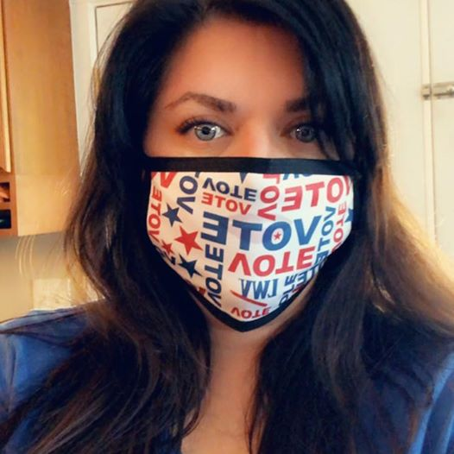

The Voter, July, 2020 Page 4

LWV Membership Renewal Time…

RENEW MEMBERSHIP NOW! (IF NOT ALREADY DONE!)

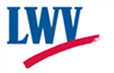

LEAGUE OF WOMEN VOTERS YAKIMA COUNTY
ANNUAL MEMBERSHIP RENEWAL DUE JUNE 30

Name:________________________________________________________________________
Address_______________________________________________________________________

Phone Numbers:
Home___________________Work__________________Cell__________________

Email_______________________________________________

Membership Categories:

_______$60 Basic*

_______$40 Each additional family member at the same residence

_______$10 Student Associate

Sustaining Gift: $60 _____ $40 _____ $25 _____ Other_______ Your Sustaining gift will help support our local activities.
*Please Note Dues Distribution: National: $32
State: 19
LWVYC retains: 9
$60
Make checks payable to: LWVYC and mail to PO Box 723, YAKIMA WA 9890

